Exercise 2: Verifying Interactions

Step -1:- Created a mock object for the external API.

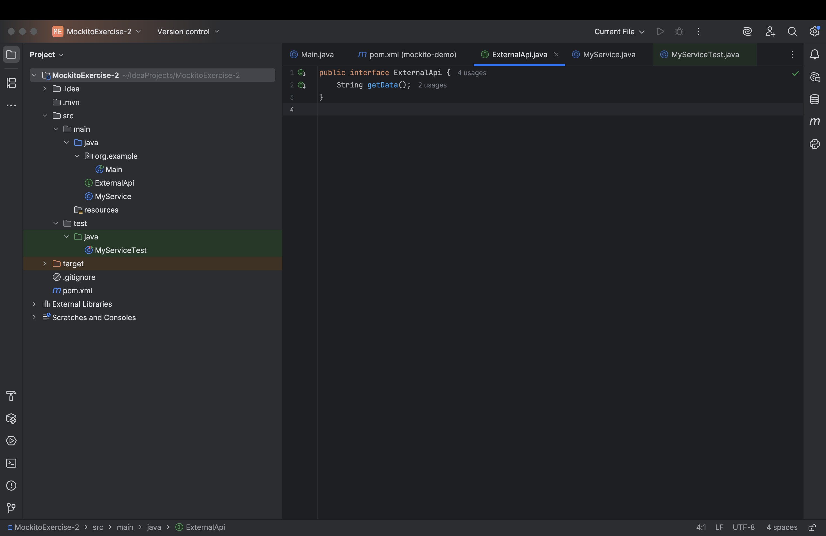

Step -2:-

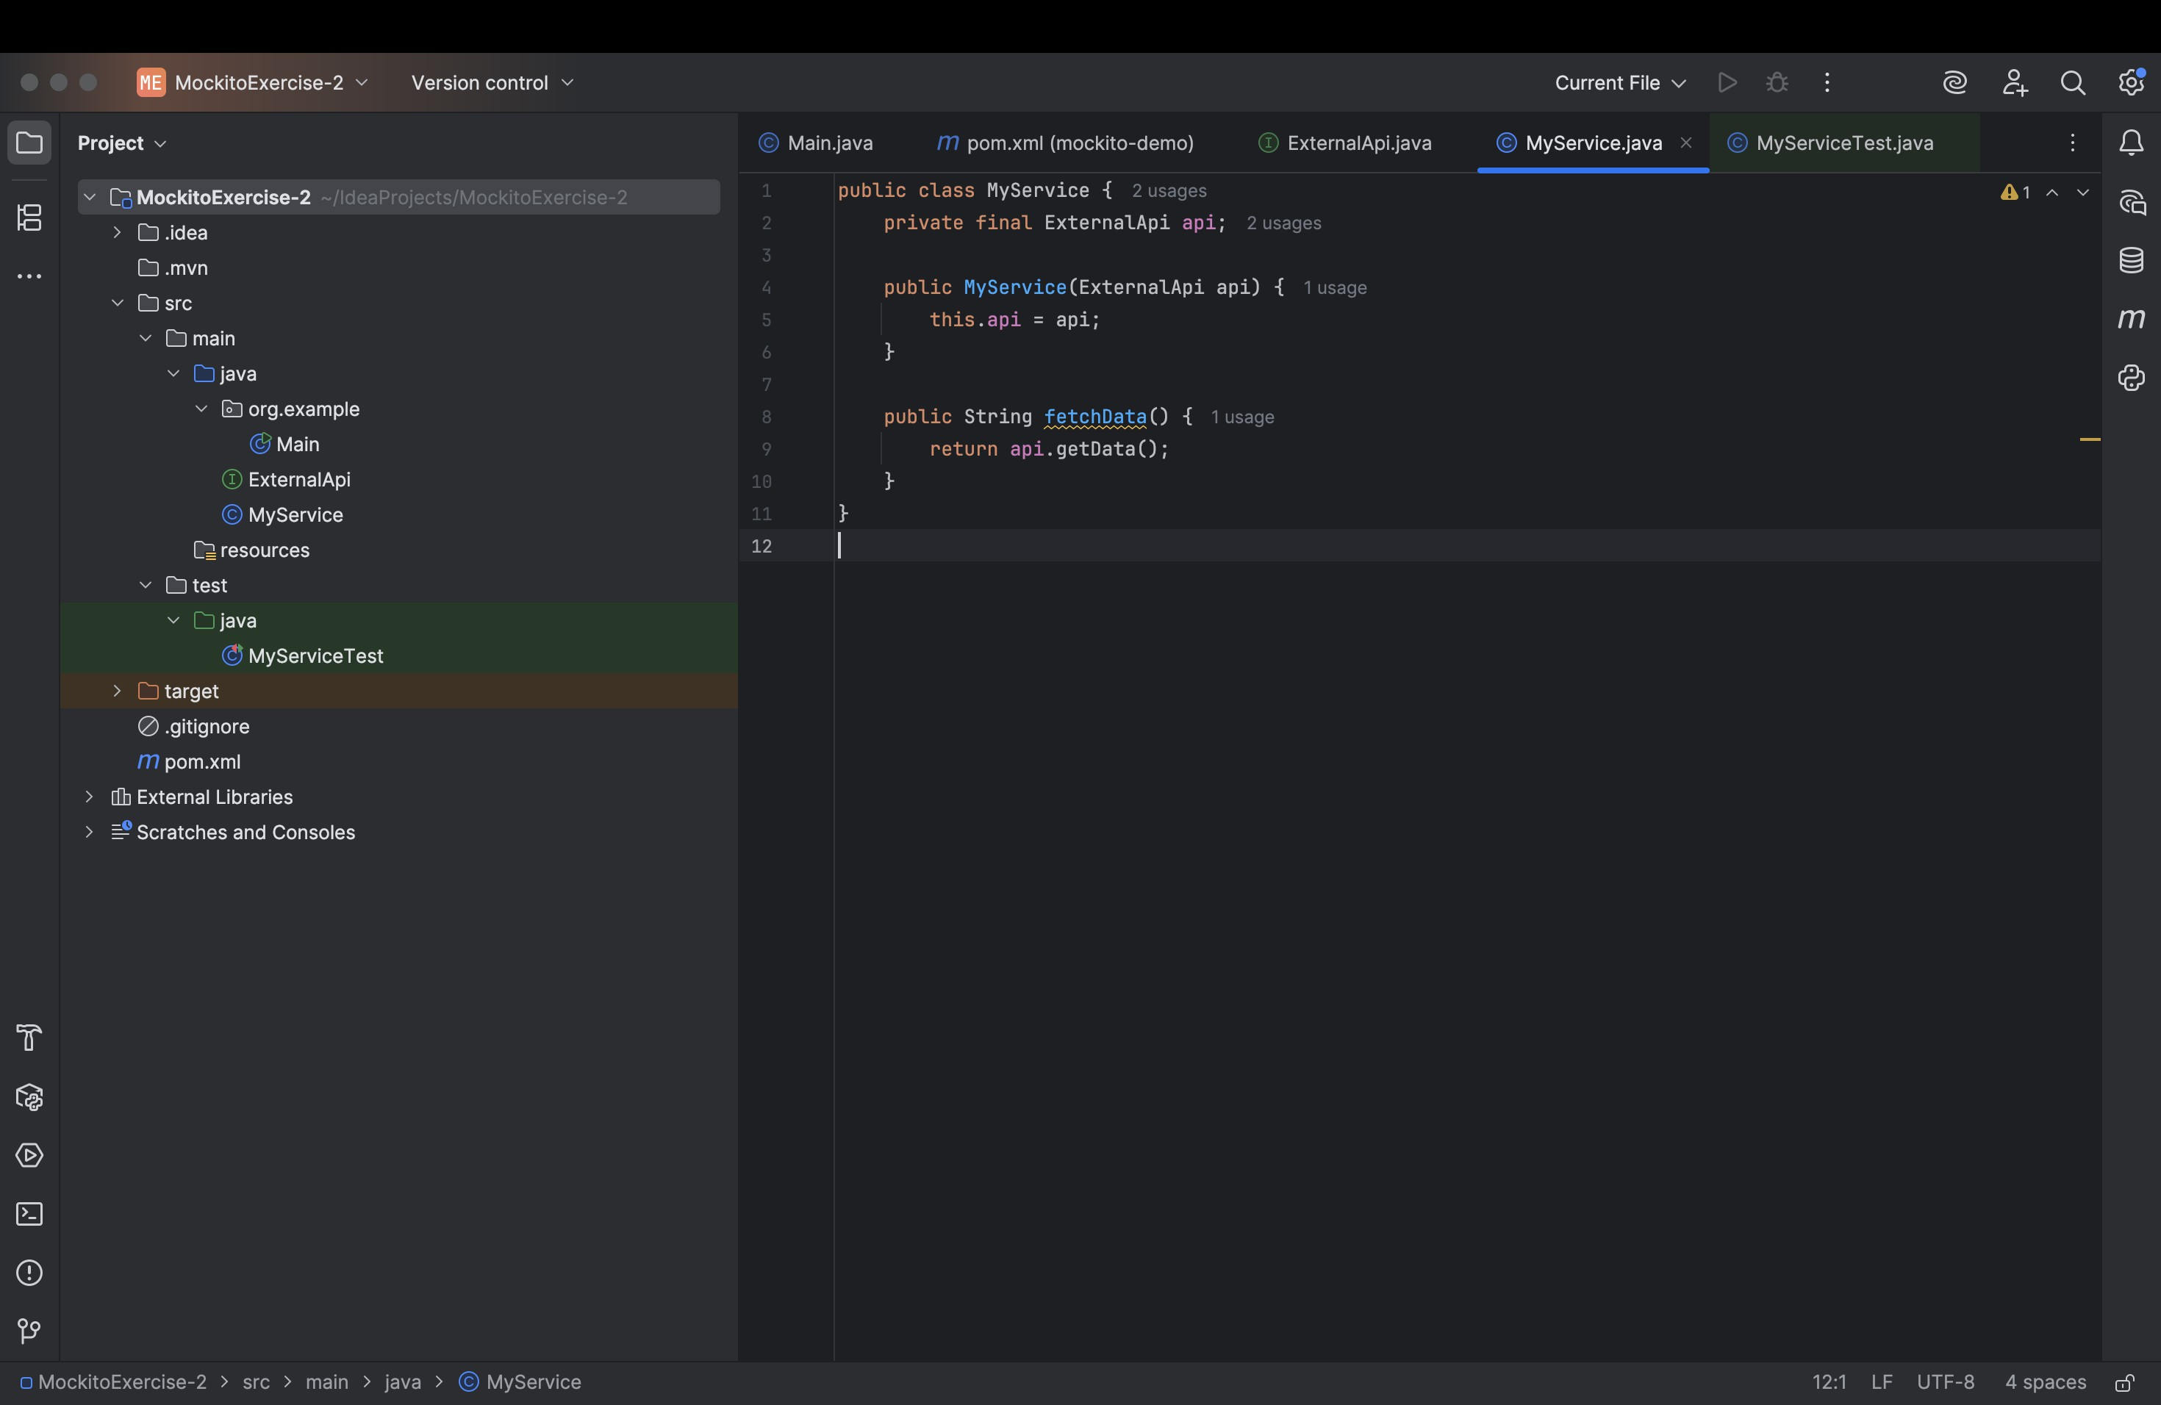

Step-3:-

Calling the method with specific arguments and verify the interaction.

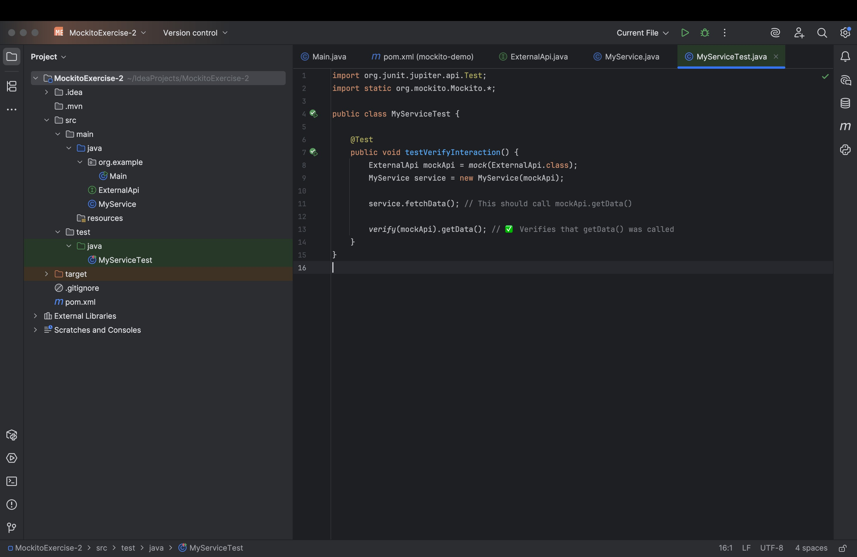

Output:-

